

Simple Perfusion Kit Assembly 8-Channel

Model # ALA SPK-8
Ver. 2.0
2024

Check before you start:
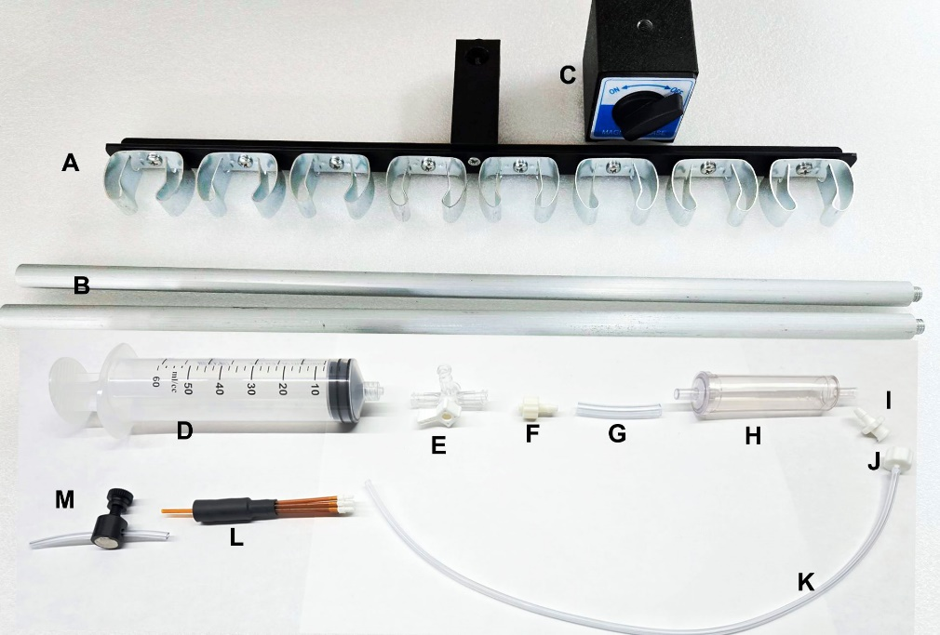

A: Reservoir Bracket x1 | B: Aluminum Bar x 2
C: Magnetic Base x 1 | D: 60ml Reservoir x 8
E: 3-way Luer Valve x 8 | F: 1/8 Male Barb Luer x 8
G: Connector Tube x 8 (4mm id) | H: Drip Chamber & cap x 8
I: 1/8 Female Barb Luer x 8 | J: 1/16 Male Barb Luer x 8
K: 1/16” id PVC Tubing x 8 (30”) | L: Minimanifold-8 (MMF-8) x 1
M: Flow Control Valve x 1

Drip Chamber Assembly:
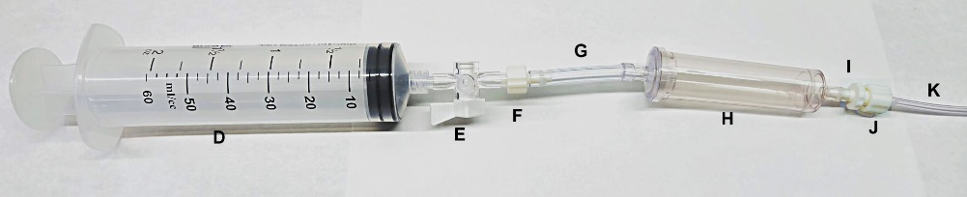
Connect the chamber, luer valve, luer fittings and tubing as shown above. Repeat for all 8 channels. Each K tubing will connect to an input of MMF-8.

Control Valve Attachment and Magnetic Stand:

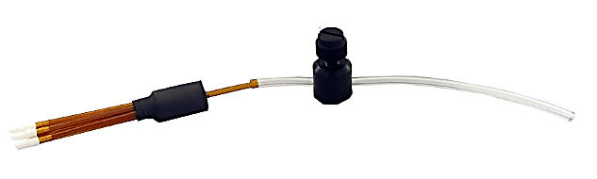
Attach Flow Control Valve to MMF-8 (L) as shown.

Set up stand as shown in image.
Each 60ml reservoir, with the rest of the drip chamber assembly, will snap into the clips attached to the bracket.

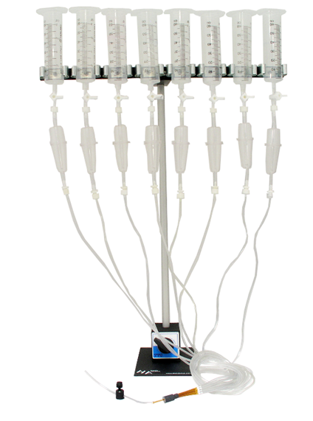
Warranty:
ALA Scientific Instruments, Inc. agrees to warranty this product against defects in material and workmanship for 30 days from the date of shipment. The remedy shall be limited to replacement or repair of the item(s) at ALA’s discretion. The usage of this product by the user will indicate the user’s understanding of the use of this product as set forth in this manual. Neither ALA Scientific Instruments, Inc., nor any of its affiliates will be held responsible for damage to laboratory equipment, including microscopes, resulting from the use or misuse of this product, including damage resulting from inputs exceeding specified limits that result in malfunction to or from this device.
If warranty repairs are necessary, shipping charges to the factory are the customer's responsibility. Return charges will be paid by ALA Scientific Instruments for warranty repairs only.
This instrument is not for clinical use. It is strictly for basic research in a laboratory setting. It has no clinical application whatsoever and cannot be used on human subjects.

